Open Hardware Controller – GitHub Setup

The OpenHardwareController Repository has been created under https://github.com/InES-HPMM/OpenHardwareController .

Software Setup
- Install Git and TortoiseGit (Windows)
- Install Git LFS (we need LFS as we have Files that are larger than 100 MB): in Windows : -> open Cmd -> enter “git lfs install”.

- Open the TortoiseGit Settings (Right Click in Explorer -> TortoiseGit -> Settings)
  - Go to DiffViewer settings.
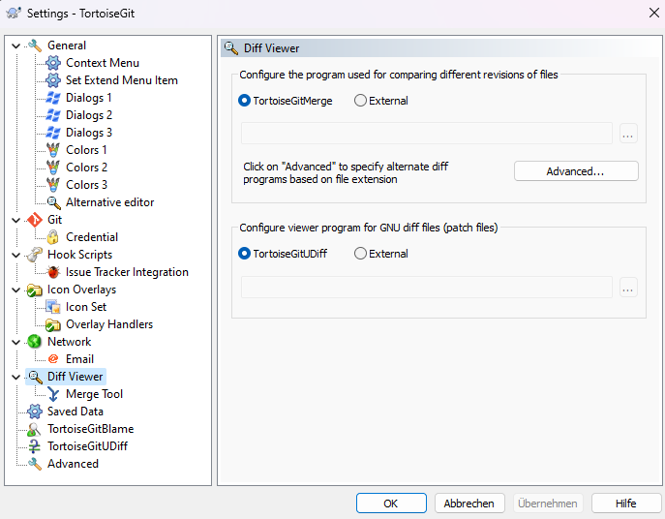
  - Under “Advanced” enter a new setting for each LabVIEW file type you want to Diff (I chose .vi, .ctl, .lvlib, .lvproj and .viaconfig) and add the LVCompare Tool (usually under C:\Program Files\National Instruments\Shared\LabVIEW Compare\LVCompare.exe) Save these Settings.
  - 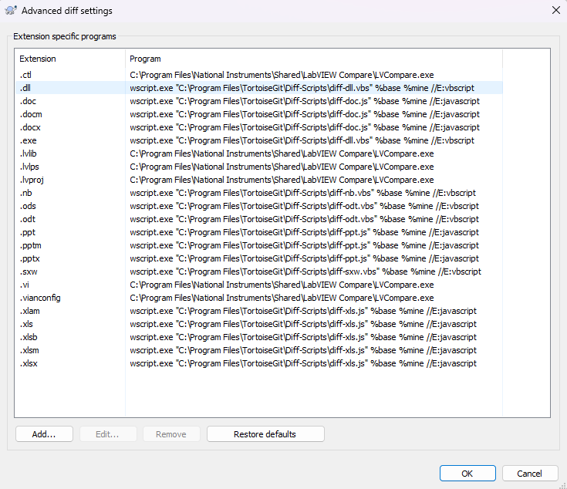

- For the merge tool the same process applies, expect now choose the LVMerge EXE
- Create an SSH key to login into github (password sign in has been deprecated) (no RSA keys are allowed). Easiest way is to use PuttyGen. Add the key to your GitHub Account
- Clone the Repository. When using TortoiseGit check the Load Putty Box and select your previously saved Private Key file:
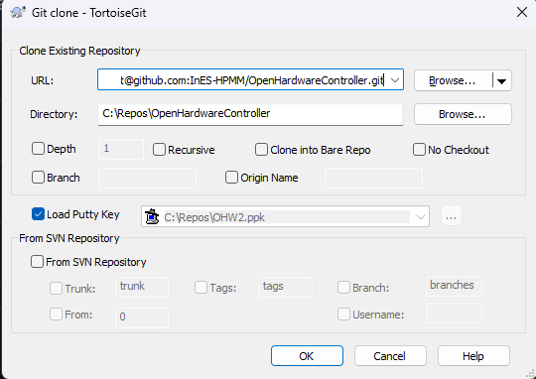

Using the Diff Function
To use the Diff Function, navigate into the Labview project folder. Right-Click -> TrotoiseGit -> Diff
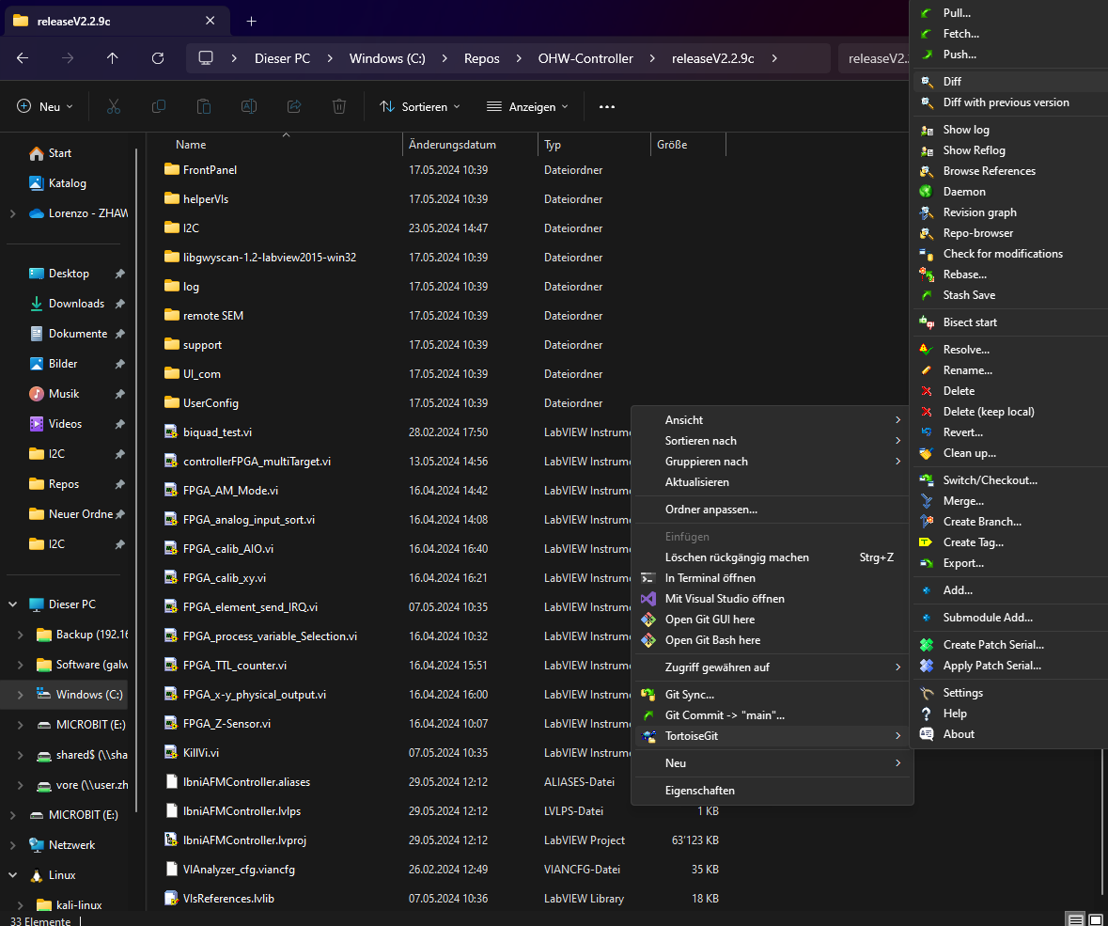
The following Window should open
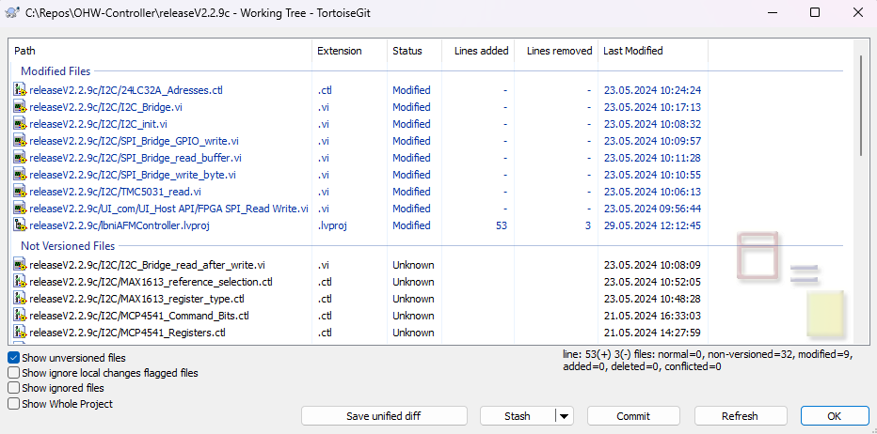
When double clicking on an item, LabView should open in Diff Mode

